- Regroup all items into separate items. (Right now many models are in the item called “table” see attached jpg) 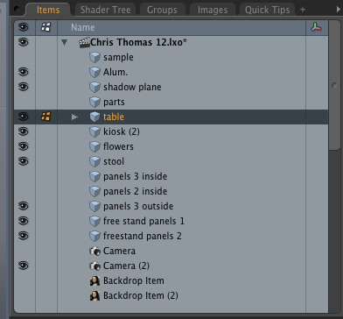

- Can you group each model like this fine grained hierarchy for easier selection and changing of materials/textures? Example is the reception counter now part of free stand panels2

3. Also please rename all materials and tex maps accordingly. In the case where a material is common across different models it can be something generic.

RecCtr (when selected all the components below are selected, but then if needed each level can be selected indiviudally)
-RecCtrTop (both the top/sides/bottom of the counter top, map with wood tex.
-RecCtrSideVert (alum profile)
-RecCtrSidePanel (wood curved panel that fits insides the alum sides)
-RecCtrHorizShelf1 (alum shelf - not present)

4. Please do this for all the items major below, breaking down major elements of the model into subgroups, and gang tex maps in UV templates only to levels of details indicated)

1. Freestanding unit1
-note that the horizontal divider bars are different from back to front, they don’t have to be in a unit. When they are back to back with a plate of alum then that is a shelf like at the top
FreeUnit1Bar1- break down into individuals bars
FreeUnit1Bar2- break down into individuals bars
FreeUnit1Bar3- break down into individuals bars

FreeUnit1Shelf1 - top shelf
FreeUnit1Front - front panel (sharedtex map called “freestand panels 1.pg”)
FreeUnit1Back – back panel (sharedtex map called “freestand panels 1.pg”)

2. Freestanding unit2 (ditto as above) (seperate out the reception counter into its own model)

3. RecCtr (see breakdown above)
4 RecCtr chair
5. Kiosk 1 – screen texmap called is screen1
6. Kiosk 2 -screen texmap called is screen2
7. Kiosk3 -screen texmap called is screen3
8. Chair1 (wood, alum, leather)
9. Chair 2
10.Chair 3
11. coffeetable (wood, glass, alum, book, flowers)
12. carpet
13. Wall

- horiz shelf dividers are ok, just give them13 separate group names Wall_horiz1, etc…
- call the curved wood end caps, cap1 and cap2
- call the 90 deg corner radius “radius”

-Break down into following groups/materials/maps plz map the provided jpg textures to the model.

Wall2In_top
Wall2In_plexi
Wall2In_base

Wall3In_top
Wall3In_plexi
Wall3In_base
Wall3In_backlit

Wall2Out_top
Wall2Out_plexi
Wall2Out_base

Wall3Out_top
Wall3Out_plexi
Wall3Out_base
Wall3Out_backlit

